The VIK Menu

Mains £7

|  |
| --- |
| Cheeseburger, skinny fries  Chicken goujons, skinny fries, baked beans  Fish Fingers, skinny fries, baked beans (*)  Tomato pasta, grated cheese |

Puddings £4

|  |
| --- |
| Chocolate brownie; vanilla ice cream, chocolate sauce (*)  Sticky toffee sponge; vanilla ice-cream, butterscotch sauce  2 scoops of Welsh vanilla ice cream (*) |

We also have a selection of cordials & soft drinks …… ask the staff for more details!!

**We Love our Football!!**

Who is your favourite player!!..........................................................................

Why not colour him in? Add some colour as long as it’s not blue!!!

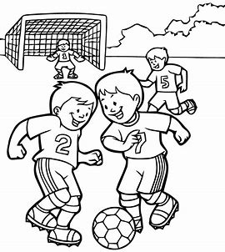

|  |  |  |  |  |  |  |  |  |  |  |
| --- | --- | --- | --- | --- | --- | --- | --- | --- | --- | --- |
| A | S | O | B | R | O | W | N | I | E | Can you find them all? |
| F | A | O | D | I | O | C | H | A | W | They can be diagonal, horizontal |
| G | U | E | D | D | L | O | U | R | W | or vertical |
| H | S | Y | F | A | T | C | I | A | D |  |
| N | A | A | A | L | U | K | X | L | A |  |
| J | G | O | T | Y | P | T | Z | K | F |  |
| U | E | B | B | H | O | A | C | J | R | Pie |
| I | S | P | O | N | I | I | V | H | E | Fishnchips |
| K | L | P | A | U | U | L | B | G | S | Juice |
| L | K | U | R | J | Z | S | E | E | H | Fatboar |
| J | R | T | Z | M | U | Y | I | R | E | Brownie |
| P | U | F | F | I | J | R | R | T | A | Ice |
| E | F | I | J | K | F | A | J | T | O | Cream |
| E | E | R | C | L | Q | U | S | V | I | Sausages |
| W | E | X | C | E | J | A | J | C | U | Fresh |
| Q | D | R | T | U | P | L | R | W | L | Fries |
| S | D | Y | U | I | O | D | M | F | K | Pasta |
| I | P | I | E | Y | I | M | L | P | L |  |
| C | R | H | Y | U | C | R | E | A | M | Can you do it in under 5 minutes?? |
| D | R | O | N | I | E | J | K | O | P |  |
| Q | T | Y | P | L | I | K | Y | U | M |  |
| F | I | S | H | N | C | H | I | P | S |  |